**Purpose:** To understand how EIGRP works and implement it in the prepared network for practice.

**Topology**

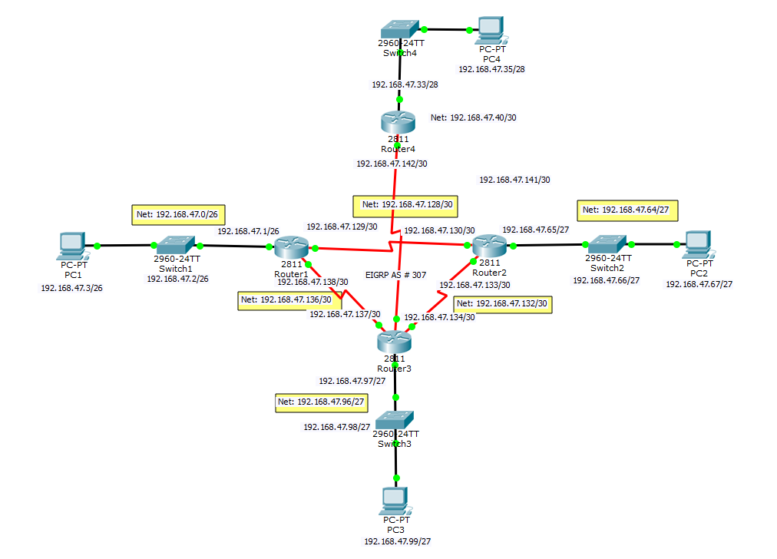

**Command Syntax**

|  |  |
| --- | --- |
| *Show IP EIGRP INT* | Displays the interfaces configured on EIGRP |
| *Show IP EIGRP Neigh* | Displays the neighbors who are connected via EIGRP |
| *Show IP Protocol* | Displays the current routing protocol of the selected router. |
| *Router EIGRP # > Network IP Wildcard Area #* | Configures the router to dynamically route packets using EIGRP protocol. Wildcard (255.255.255.255 – Subnet Mask) |

**Verification**

PC1 Ping & Tracert

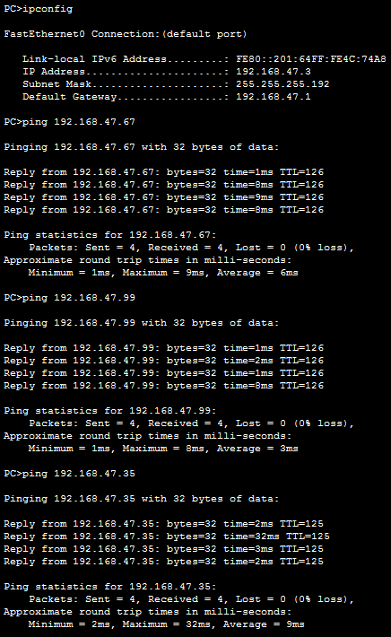

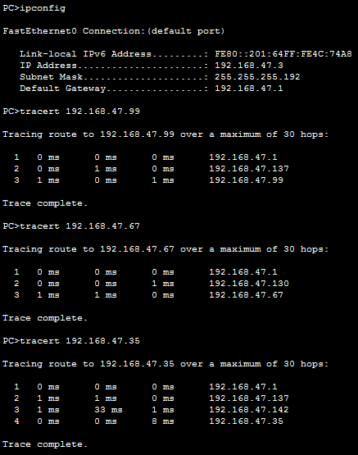

PC2 Ping & Tracert

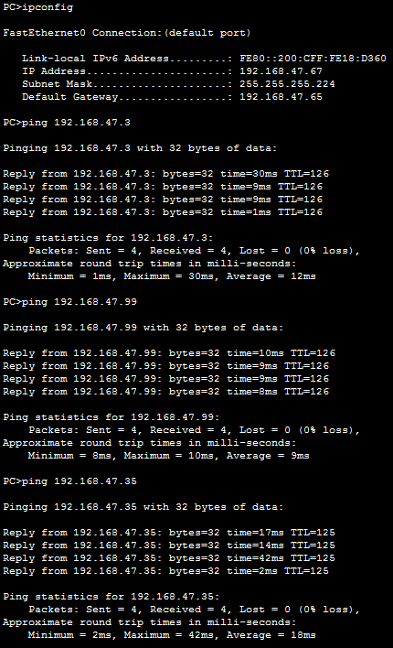

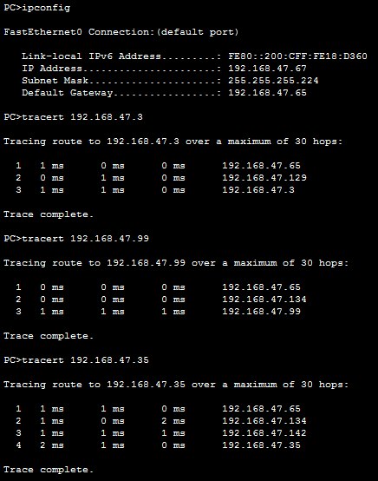

PC3 Ping & Tracert

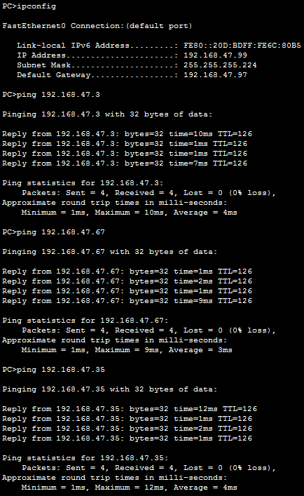

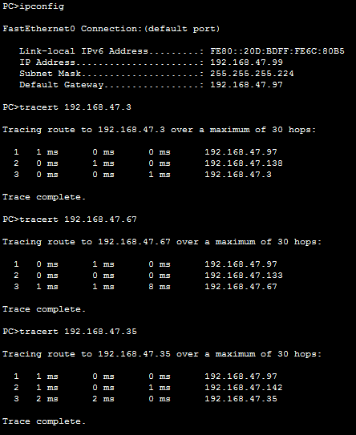

PC4 Ping & Tracert

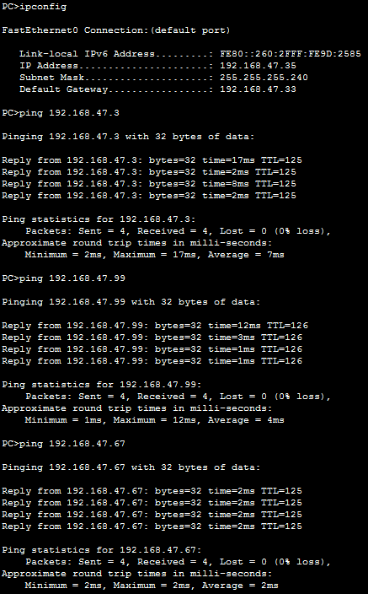

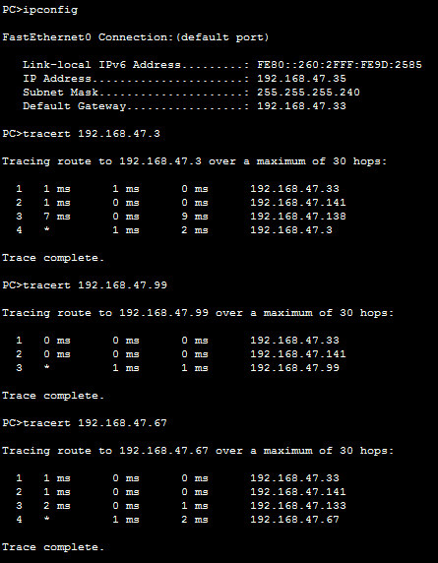

Router1

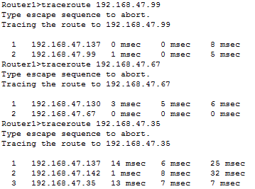

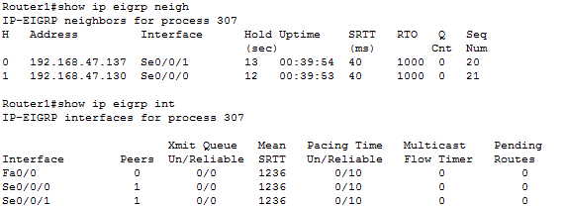

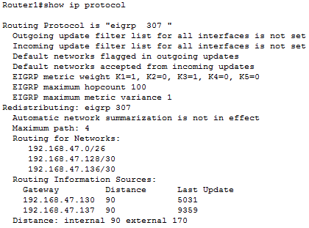

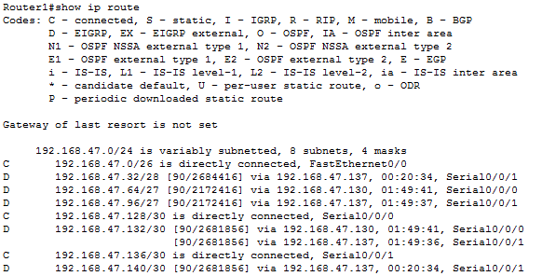

Router2

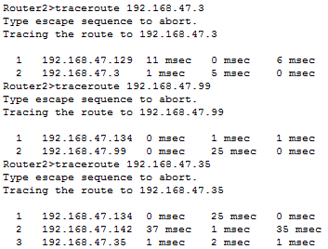

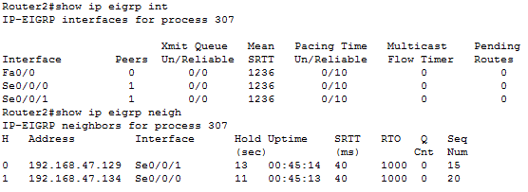

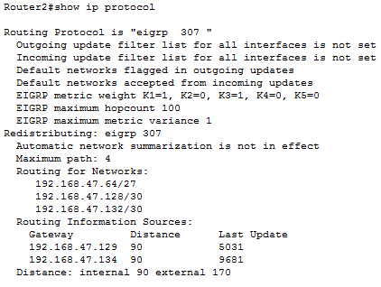

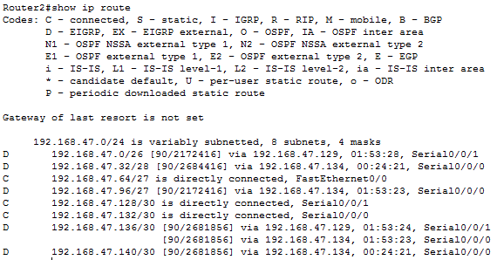

Router3

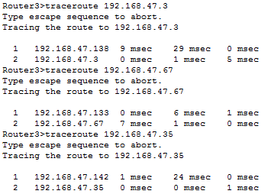

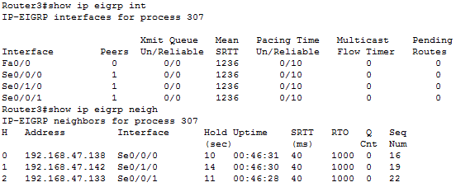

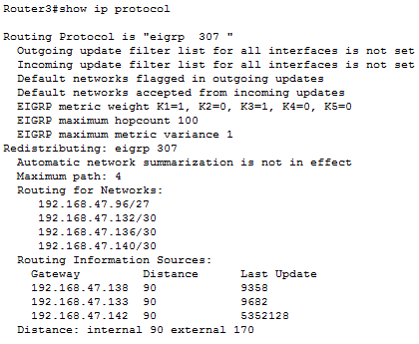

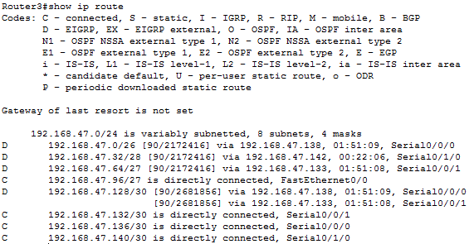

Router4

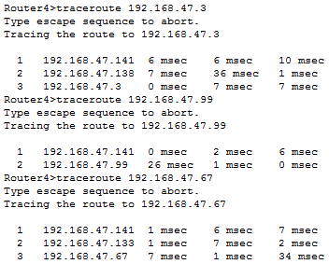

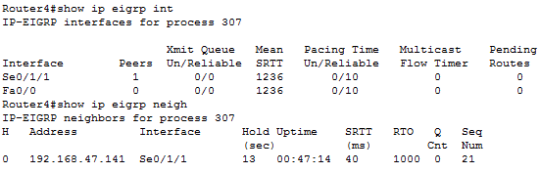

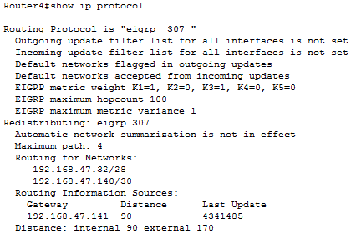

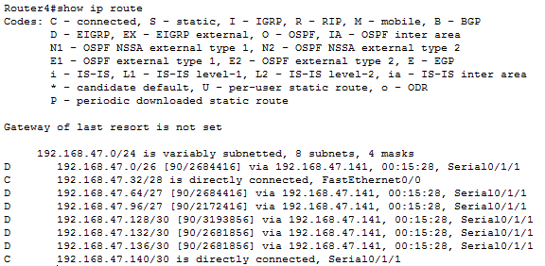

**Results/Outcome**

This lab took a little more time and thought than usual, simply due to the fact that we had to calculate the IP addresses. However simply looking at the topology that has been set up allows us to assume what some IP addresses should be.